Module 9 Challenge

Q1. List the employee number, last name, first name, sex, and salary of each employee.

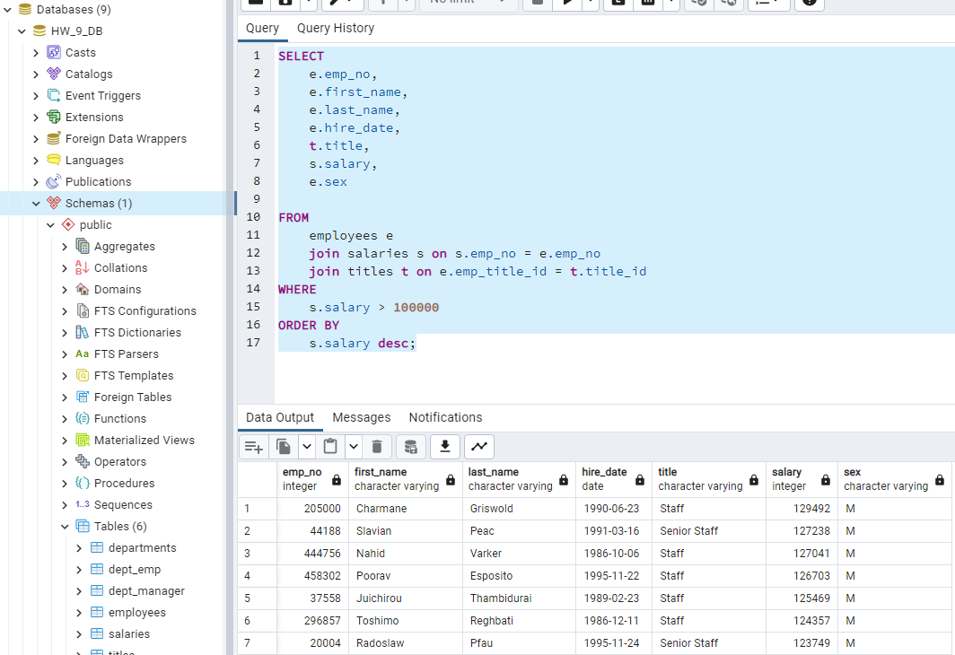

Q2.